COMPUTER SCIENCE 378: INTRODUCTION TO DATABASE MANAGEMENT
Assignment 3
Jackson Wiebe 3519635
Total: 100 marks
Weight: 15% of your final grade
Due: After you have completed Unit 8.
Answer all of the following questions, and upload your completed work here.

Question 1 (18 marks)
Consider the following dimensions, dimension attributes, and dimension sizes for Farm Coop-Insurance.
- Member(member_ID, Name, Address). On average, there are two members for each policy and item covered by the policy.
- InsuredItem(Item_ID, Description, Coverage_Type). There is an average of ten covered items per policy.
- CoopOffice(Office_ID, Address, Manager_name). Each policy is registered and managed by only one office of the cooperative.
- Policy(Policy_ID, Type). The company has approximately one million policies at the present time. Approximately five percent of these policies experience some change each month.
- Period(Date_Key, Fiscal_Period). The length of the fiscal period is one month. The decision system reports are supposed to be based on five years of data.
- Claim(Claim_ID, Claim_Description, Claim_Type).
The facts to be recorded for each combination of these dimensions are: Policy_Premium, Deductible, and Monthly_Claim_Total.
- Design a star schema for this problem.
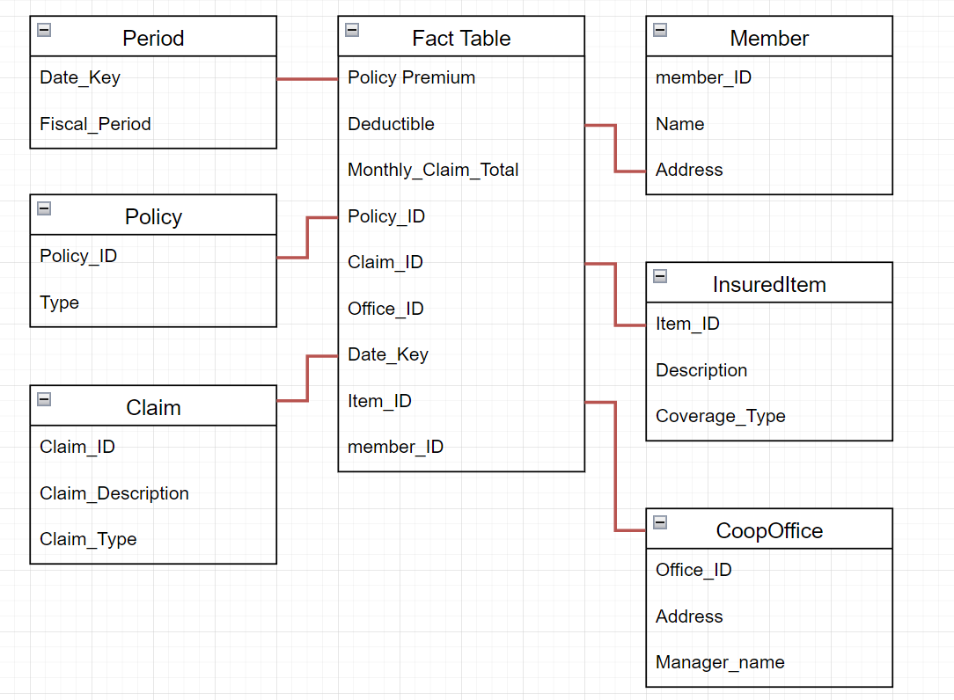
- Using the assumptions stated above, estimate the number of rows in the fact table.
The Company has approximately 1 million policies at the present time. With 5% change per month that is 50k new records. If the dataset is 5 years old we have at minimum 1,000,000 + (50,000 * 12 * 5) = 4,000,000 records.
- Estimate the total size of the fact table (in bytes), assuming an average of 5 bytes per field.
If the fact table has 9 columns and 4,000,000 rows the total table size is 9 * 4,000,000 * 5 = 180,000,000 Bytes

Question 2 (20 marks)
Suggest an appropriate recovery technique that a database administrator could use to resolve each of the following situations.
- A network disconnection occurs while a user is entering a transaction at an ATM bank machine.
Since this is a financial terminal, robust 2 way communication must be verified on both ends. If the communication is interrupted before both ends confirm the transaction then it should be considered Abort. The database will rollback that specific change. The transaction is canceled and the user terminal can lock out the user or try again.
- A disk drive fails during regular operations while a clerk is entering data about newly registered students.
If possible, switch to a duplicate database. Or abort the transaction and attempt to rollback the requested changes.
- The registration office at a university entered an incorrect amount for a student tuition payment. The error was discovered by the financial services department several weeks later.
The suggest approach is to rollback the table. The administrator should also have journalizing facilities in place so that other users can see this correction if an investigation takes place.
- The database administrator of a financial institution performed a full database backup, but forgot to activate the journalizing facility. Afterwards, data entry clerks at the financial institution entered transactions for two hours before the database became corrupt. It is discovered that the journalizing facility of the database has not been activated since the backup was made.
A forward recovery should be performed to merge the backup with any valid transactions in the current database. The administrator should then perform a backup after the merging and journaling should proceed as normal.

Question 3 (20 marks)
Suggest the most appropriate security measures for each of the situations described below.
- The Western Union bank uses an electronic funds transfer (EFT) system to transmit sensitive financial data between its branches all over the world.
Personnel controls will the most important consideration here. Ensure that each user can only access their own accounts and only a small set of administrators can modify any account. There should be policies in place to ensure that staff changes are quickly dealt with and authorization is kept tight.
- A fighter jet simulation company has set up an off-site computer-based training centre for the F35. The company wishes to restrict access to the site to authorized employees. Since each employee's use of the centre is occasional, it does not wish to provide the employees with keys to access the centre.
One Time Use Keys would help this administrator. The employee would request a new access key for each session. After its use the key is invalid and a new key must be requested for each session. Secondarily the administer could apply these keys to a user’s building access card so the transaction is more seamless to the end user.
- A golf club uses a simple password system to protect its database. The club has created a new Web site to allow both its members and its employees to use the new Web-based system to access and update information. The club finds that it needs a more comprehensive security system to grant different privileges (such as read-only versus create or update) to different users.
The use of Authorization rules would help this company restrict access on a per user basis. The permissions can be applied per database or down to the table level. Such that administrators should have the ability to reset customer passwords but not visaversa.
- A training centre at the Northern Technical University has experienced considerable difficulty with unauthorized users who access files and databases by appropriating passwords from legitimate users.
This data centre should implement 2 factor authentication. The secondary authorization method should not include the use of emails. Typical solutions include dedicated hardware, smart cards, activator code /apps, verification of security information like security questions.

Question 4 (12 marks)
The UBS broker company has a database server with three disks. Both the accounting and stock exchange applications share the same disk, and they are experiencing performance problems. Discuss potential reasons for the performance problem, and suggest how to reduce I/O contention.

Question 5 (10 marks)
Consider the concurrent execution of the following transactions.
T1 | T2
Read A | Read B
Read B | Write A
Write C | Read C
Write A | Write B
Commit | Commit
List two problems that may occur from the concurrent execution of these two transactions.

Question 6 (20 marks)
The Edmonton International Airport would like to implement a database that will be used to keep track of airplanes, their owners, airport employees, and pilots. From the requirements for this database, the following information was collected.
- Each airplane has a registration number, is of a particular plane type, and is stored in a particular hangar.
- Each hangar is managed by an employee who supervises the maintenance services performed in that hangar.
- Each plane type has a model number, a capacity, and a weight.
- Each hangar has a number, a capacity, and a location.
- The database keeps track of the owner of each plane, and the employees who have maintained each plane.
- The database keeps track of each airplane’s purchase date.
- Each maintenance service record is identified by a work code, and includes the employee who performed the service, the date and time of the service, and the number of hours the maintenance service required.
- Each plane undergoes service many times, and all its service records are kept.
- An owner can be either a person or a corporation.
- A person can be an owner, a pilot, or an employee of the airport.
- Each pilot has specific attributes, including license number and restrictions.
- Each employee has specific attributes, including salary and shift worked.
- The database stores social insurance number, name, address, and telephone number for all person entities.
- The database stores name, address, and telephone number for all corporation entities.
- The database also keeps track of the types of plane each pilot is authorized to fly, and the types of plane each employee is qualified to service.
Draw an object-oriented diagram for the Edmonton International Airport database.

